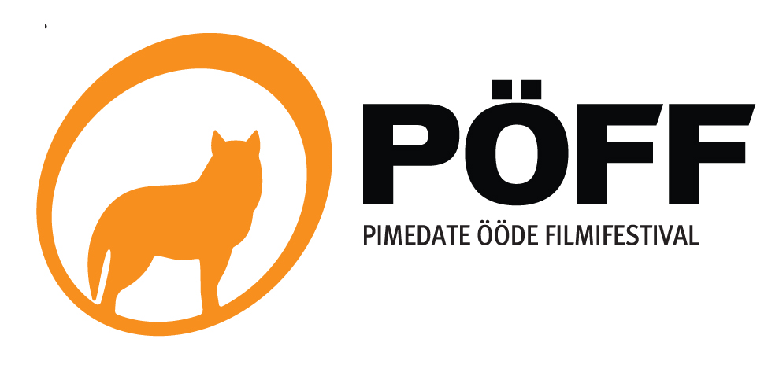
PRESS ACREDITATION FORM
Deadline: November 6, 2009
Applicant:
First name: |  |  | Last name:
Position: |  |  | Publication:
Contact telephone: |  |  | E-mail:
Main Medium: | □ Newspaper □ Radio □ Television □ Internet □ Freelancer
Company`s address:

Business phone: |  |  | Business fax:
General e-mail: |  |  | Homepage:
Chief Editor: |  |  | Signature of Chief Editor:
 |  |  | Applicant`s signature:
Accreditation fee
The accreditation fee of 40 EUR (630 EEK) should be paid in cash upon receiving the accreditation badge at the PÖFF guest information desk in Nordic Hotel Forum from 27.11.2009 (Viru väljak 3; Tallinn)

Main information
- Accreditation includes Festival catalogues, screening schedule and other informative materials
- Accreditation badge is valid for all PÖFF regular screenings from 12th of November until 6th of December 2009 (main programme, Sleepwalkers, Animated Dreams, Just Film) in appointed festival venues depending on the availability of free seats. Accreditation badge is also valid in other towns where PÖFF films are screened. Closer instructions are given when the badge is issued.
- Accreditation badge allows entrance to all press screenings in appointed venues depending on the availability of free seats.
- Accreditation badge allows entrance to all Festival press conferences.
- Accreditation badge allows the usage of festival video library. Advance registration recommended.
- Ticket is valid only with the accreditation badge. Misuse of the badge will result in confiscating the badge and invalidating the accreditation.
- A personal accreditation badge will be issued to the applicant. Forwarding the badge to third persons is prohibited.
- Owner of the accreditation badge is obliged to follow the general rules of the Festival and of the screening venues.
- Festival has the right to refuse any application which does not meet its criteria.

Please send us any articles, TV shows etc. published about PÖFF to the following address press@poff.ee or Telliskivi 60 A, 10412 Tallinn, Estonia.

